Where successful submission of the violation sends an email to the violator and notification emails to all admin accounts.

# parking.php

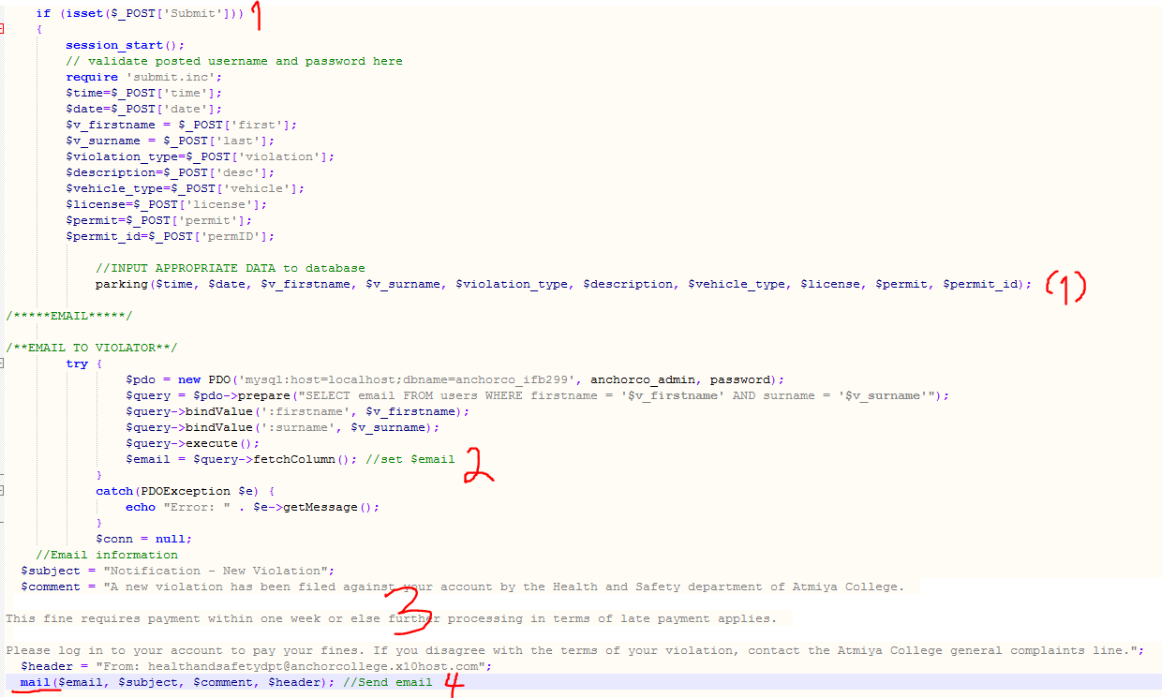

Step 1:

After successfully submitting the form…

Step 2:

…Retrieve email address of violator from the firstname and surname submitted in the report

Step 3:

Set variables with correct information

Step 4:

Use the mail() PHP function to send the email

(P.T.O.)

# parking.php (cont.)

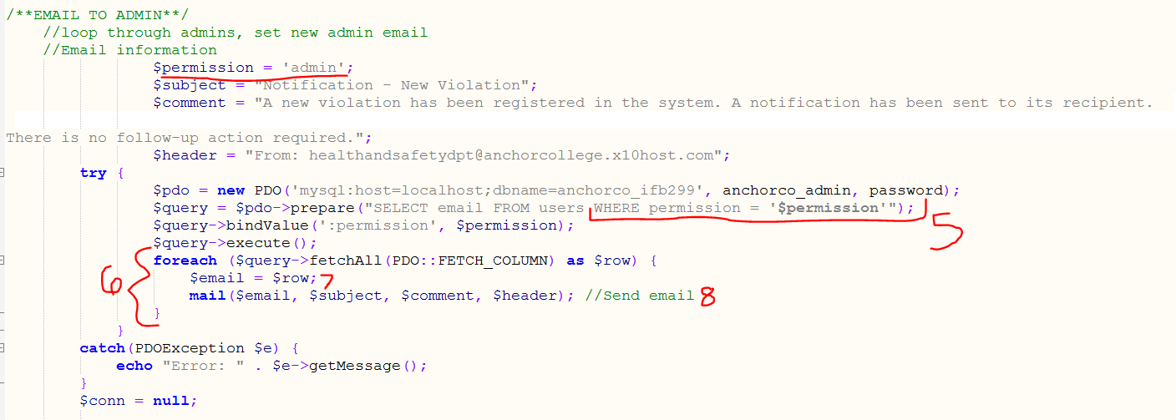

Step 5:

Retrieve all users from database where permission = admin

Step 6:

Loop through these users,

Step 7:

Set their email address,

Step 8:

Send them the admin email